**Technical University of Moldova**

**Faculty of Computers, Informatics and Microelectronics**

**Department of Software and Automation Engineering**

**Laboratory work No. 3**

**Domains, Constraints**

**Elaborated: Dan Hariton**

**st. FAF-211**

**Checked: Elena Graur**

**un. assistant.**

**Chişinău, 2024**

**1 THE TASK OF THE LABORATORY WORK**

As usual, life in Luna-City is bright and peaceful! Marvelled by engineering and technology, it boosts the quality and enjoyment of life. However, not all the places on the Moon are as shiny and peaceful as Luna-City. One day, unexpectedly the Kepler Observatory, the space research center of the Kepler University, intercepts a mysterious Signal from the Dark Side of the Moon. The signal is encrypted and no clue of what is its meaning or purpose. All that is known is the data being embedded on a series of 9x9 square grids, with some numbers on them. It might be a ”Hello World” from a potential friend or a death threat from a warrior nation. And who knows which is which, and who is who? The government had nothing left but to contact ”HeinleinAI” to get some help! Taking into consideration your previously successfully solved tasks, your company decided to assign you to this important mission. So, in an isolated room, staying all by yourself, you have been nervously waiting for the promised materials. Two men from the government, all dressed in black, put on your desk a heavy-looking metal container with a paper label on its lid stating Secret Unknown Data Observations from Kepler University (SUDOKU). Feeling afraid and determined, you are ready to start your mission - to solve these number puzzles on paper, narrowing down the possibilities until you uncover the hidden code. You realize that each solved paper might bring you closer to unlocking the secret of the signal. The fate of Luna-City, and perhaps all of humanity, may rest in your hands. Be aware! The clock is ticking, so you should be both fast and precise.

**2 THE PROGRESS OF THE WORK**

**2.1 Implement a solution for solving the SUDOKU puzzles using backtracking.**

This task was to develop a Sudoku solver that fills empty cells in a partially completed grid using a recursive backtracking algorithm. This algorithm systematically attempts to place values in each cell while adhering to the constraints of Sudoku.

Example:

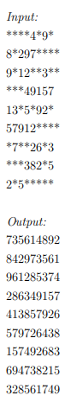

BacktrackingAlgorithm: Backtracking is a recursive approach to solving constraint satisfaction problems. For Sudoku, it involves:

* Trying values from 1 to 9 in each empty cell.
* Checking if placing a number violates Sudoku rules (unique numbers in rows, columns, and 3x3 sub grids).
* Proceeding if a placement is valid, and backtracking if it leads to a dead end (i.e., if no valid placements are left).

GridSetup: We allowed the user to input a Sudoku grid where * represents empty cells, which our code internally converts to 0 for processing.

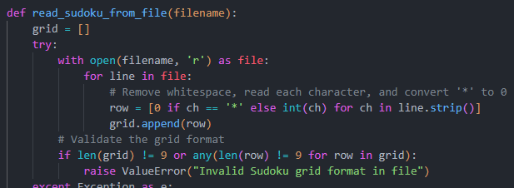

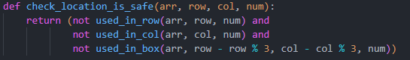

The solve sudoku function is the core of our backtracking approach. It finds an empty cell and tries placing numbers 1 through 9, checking each time if the placement is valid. If it finds a solution, it returns True; if not, it backtracks.

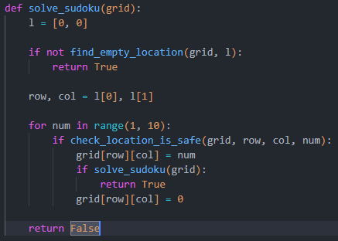

**2.2 Define each cell’s domain and implement Constraint Propagation to eliminate impossible values for each cell.**

This task was to reduce the possible values (domains) of each cell by eliminating values that would violate Sudoku rules. By propagating constraints across the grid, we minimized the number of possible choices in each cell’s domain, which helped streamline the solving process.

* Domain Initialization: Each cell in the grid has a set of possible values (1 to 9). For cells that already have a value, the domain is restricted to that single value. For empty cells, the initial domain is all values {1, 2, 3, 4, 5, 6, 7, 8, 9}.
* Constraint Propagation: We iteratively removed values from each cell’s domain based on constraints from neighboring cells (same row, column, or 3x3 subgrid). If a cell’s domain reduced to a single value, we assigned it that value and continued to propagate constraints.

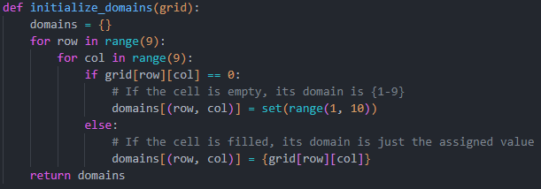

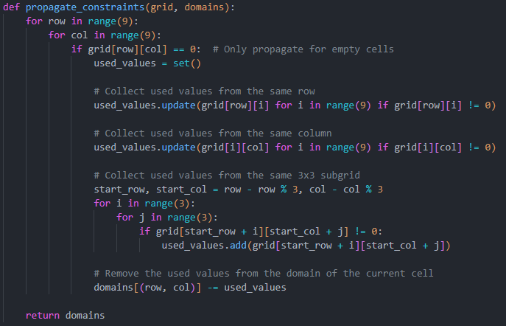

The update_grid_with_domains function assigns a value to a cell if its domain has been reduced to a single option. This assignment propagates further constraints to neighboring cells.

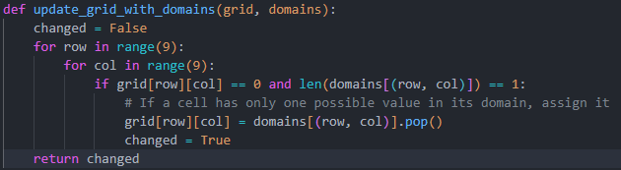

**2.3 Combine the Backtracking algorithm implemented earlier with Constraint Propagation. Implement Forward Checking to further reduce the domains (e.g. if you assigned a cell the value of 1, you will eliminate this possible assignment for the same 3x3 grid, row, or column).**

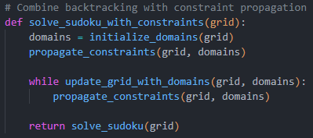

**2.4 Instead of Backtracking, implement a heuristic algorithm and combine it with the Constraint Propagation implemented earlier. (2p.) Note: you can get bonuses for implementing more algorithms. For the second algorithm you get 0.5p, for 3rd you get 0.25p, for 4th- 0.125p and so on.**

this task was to improve the Sudoku solver by combining the MRV heuristic with constraint propagation. The MRV heuristic prioritizes the most constrained cells (those with the fewest possible values) first. This often leads to a more efficient solution by addressing the cells that offer the least flexibility in value assignment early on:

* **The MRV heuristic selects the cell with the smallest domain (fewest possible values) that is still unassigned.**
* **This approach minimizes the chance of needing to backtrack by filling in the most constrained cells first**.
* Constraint propagation techniques from Task 2 were retained to further reduce domains dynamically as cells are assigned values.
* After assigning a value to a cell, we propagate this choice to its neighboring cells (same row, column, and 3x3 subgrid), updating their domains.

The find_mrv_location function scans the grid to find the cell with the smallest domain that hasn’t yet been assigned a value. This is the cell where we apply the MRV heuristic.

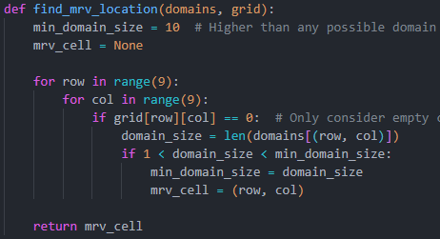

The solve_sudoku_with_mrv_and_constraints function combines the MRV heuristic with constraint propagation. It starts by setting up domains for each cell, applying constraint propagation, and then uses the MRV heuristic to decide the order of assignments.

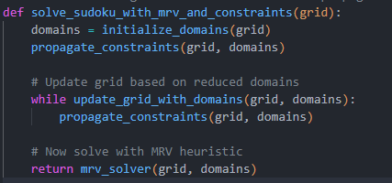

**2.5 Generate valid SUDOKU grids that your algorithm would solve.**

In Task 5, we added functionality to generate valid Sudoku grids that can serve as solvable puzzles. This required creating a fully solved Sudoku grid first and then removing numbers to create an "unsolved" puzzle that maintains a unique solution

* Generate a Full Grid: We started with an empty 9x9 grid and filled it using a recursive approach that assigns random numbers in each cell, checking for conflicts to ensure Sudoku rules are met.
* Randomly Remove Numbers: Once we had a completed grid, we removed numbers one at a time to create an unsolved puzzle. We controlled the difficulty level by specifying how many numbers (clues) should remain.

The generate_full_sudoku_grid function initializes an empty grid and fills it with numbers from 1 to 9 in a random order, checking each placement to ensure no conflicts. This approach uses backtracking to complete the grid while adhering to Sudoku constraints.

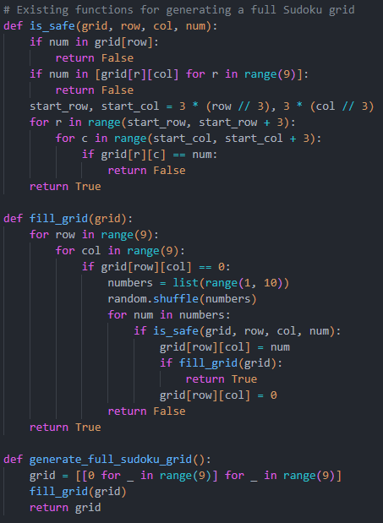

The create_unsolved_sudoku function takes the completed grid and randomly removes numbers to generate an unsolved puzzle. The number of clues (remaining filled cells) can be controlled to adjust the puzzle’s difficulty.

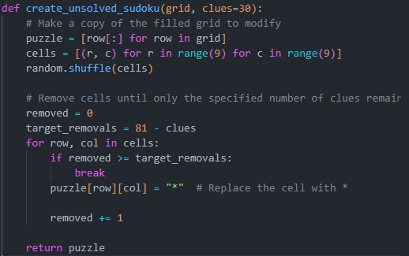

**2.6 Handle invalid SUDOKU puzzles by determining whether the provided grid is solvable.**

In this task, I implemented a method to determine whether the provided grid is solvable. This involved checking if the initial grid contains any conflicts (making it unsolvable) and verifying that it can be completed using our solving functions.

The is_valid_sudoku function checks for any conflicts in rows, columns, and subgrids. If duplicates are found in any of these, it returns False, marking the grid as unsolvable.

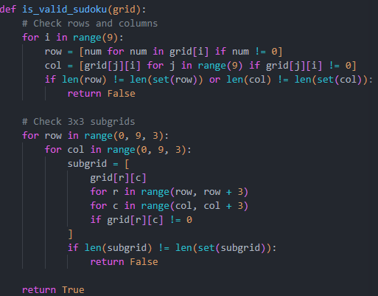

The is_solvable_sudoku function first calls is_valid_sudoku to ensure there are no conflicts in the initial grid. Then, it attempts to solve the grid using one of the solving functions. If the solver finds a solution, the grid is considered solvable.

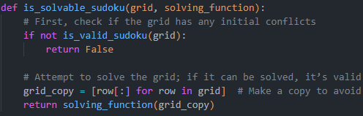

**2.7 Implement the Constraint Propagation algorithms to improve your solution. You can choose from a variety of existing ones, such as AC (AC-3, AC-2001, etc.) family, PC, BAC, DAC, etc.**

This task was to implement AC-3 (Arc Consistency 3), a constraint propagation algorithm, and integrate it with the existing Sudoku solver. By enforcing arc consistency, we systematically reduce the domains of each cell to contain only values that do not conflict with neighboring cells. This helps eliminate potential values early and may, in some cases, solve the puzzle without backtracking.

* Arc Consistency: For each pair of neighboring cells (or “arc”), we ensure that the domain of one cell (variable) remains consistent with the domain of the other. If a value in one cell’s domain conflicts with its neighboring cell’s domain, that value is removed.
* AC-3 Algorithm: The AC-3 algorithm iteratively enforces arc consistency across all pairs of neighboring cells until no further changes occur.

Implementation Steps:

* Define “arcs” or pairs of neighboring cells that share constraints (cells in the same row, column, or 3x3 subgrid).
* Apply the AC-3 algorithm to repeatedly check and reduce cell domains based on neighboring cells.
* Integrate AC-3 with the existing constraint propagation steps and backtracking.

The get_arcs function sets up pairs of neighboring cells (arcs) based on shared constraints. Each cell is paired with other cells in the same row, column, and subgrid.

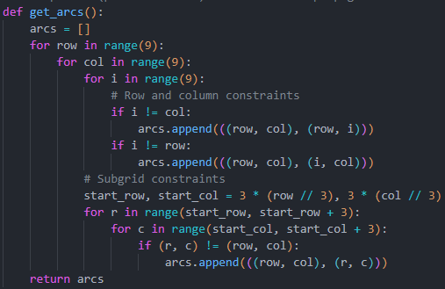

The ac3_algorithm function uses a queue of arcs and iteratively enforces arc consistency by removing values from a cell’s domain if they are inconsistent with neighboring cells. The revise function removes values from one cell’s domain if they conflict with values in a neighboring cell’s domain. This function is called by the ac3_algorithm function during each arc check.

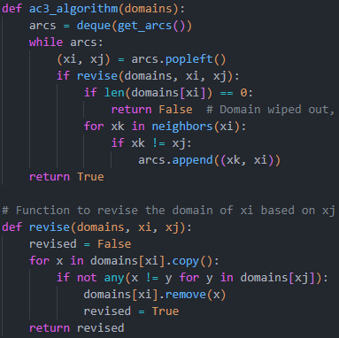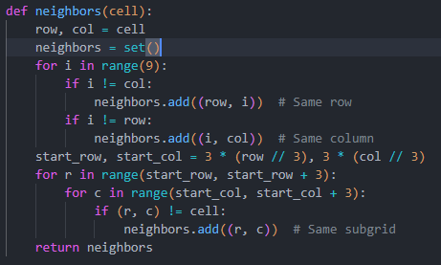

We integrate AC-3 within the solve_sudoku_with_constraints function. We first apply AC-3 to reduce domains before falling back on backtracking if needed.

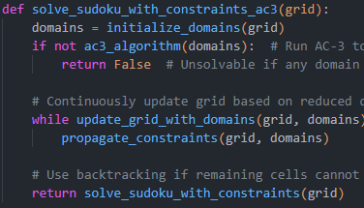

**CONCLUSIONS**

In this laboratory work, I successfully implemented several algorithms to enhance the efficiency and accuracy of a Sudoku solver. Starting with a basic backtracking algorithm, I created a solver that could systematically explore possible values for each cell while adhering to Sudoku constraints. Building on this foundation, I implemented constraint propagation techniques to reduce the potential values for each cell by eliminating conflicts in rows, columns, and sub grids, effectively streamlining the solving process.

To further optimize the solver, I integrated the Minimum Remaining Values (MRV) heuristic, which prioritized cells with the fewest possible values first. This heuristic, combined with constraint propagation, allowed the solver to make more informed decisions early on, reducing the likelihood of needing to backtrack. I extended the solver’s capability by implementing the AC-3 algorithm, a more advanced constraint propagation technique that enforced arc consistency across all cell pairs. This algorithm significantly pruned the search space by iteratively narrowing down cell domains based on constraints from neighboring cells, enabling the solver to handle even complex puzzles with improved efficiency.

Additionally, I developed functionality to generate valid Sudoku grid**s** and produce unsolved puzzles with varying levels of difficulty, ensuring the puzzles remained solvable with a unique solution. Finally, I incorporated error handling mechanism**s** to detect and reject invalid or unsolvable grids, enhancing the solver’s robustness and usability.

Overall, this combination of intelligent algorithms and advanced constraint propagation techniques allowed the Sudoku solver to efficiently handle a wide range of puzzle difficulties, providing a comprehensive and optimized solution for solving Sudoku puzzles.

**BIBLIOGRAPHY**

**1**. Lague, Sebastian. “Algorithms Explained – Minimax and Alpha-Beta Pruning.” *YouTube*, 20 Apr. 2018, [www.youtube.com/watch?v=l-hh51ncgDI](http://www.youtube.com/watch?v=l-hh51ncgDI) . Accessed 4 Oct. 2024.